**Sunkari Manohar**

**Daily Assesssment 4 – 02/01/2024**

**Azure databricks**

* Today we did hands on practice for creating delta tables with existing csv files and project overview
* Create on launch workspace

We need to create a new table by uploading the existed csv file.

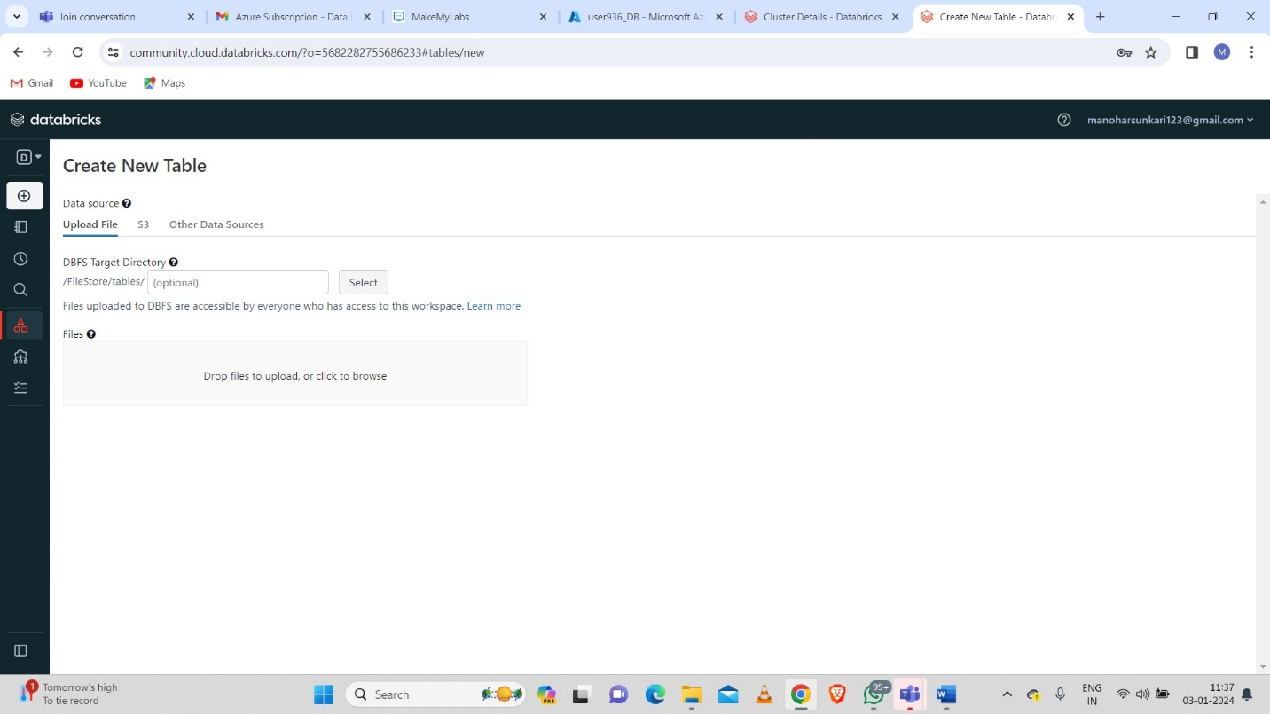

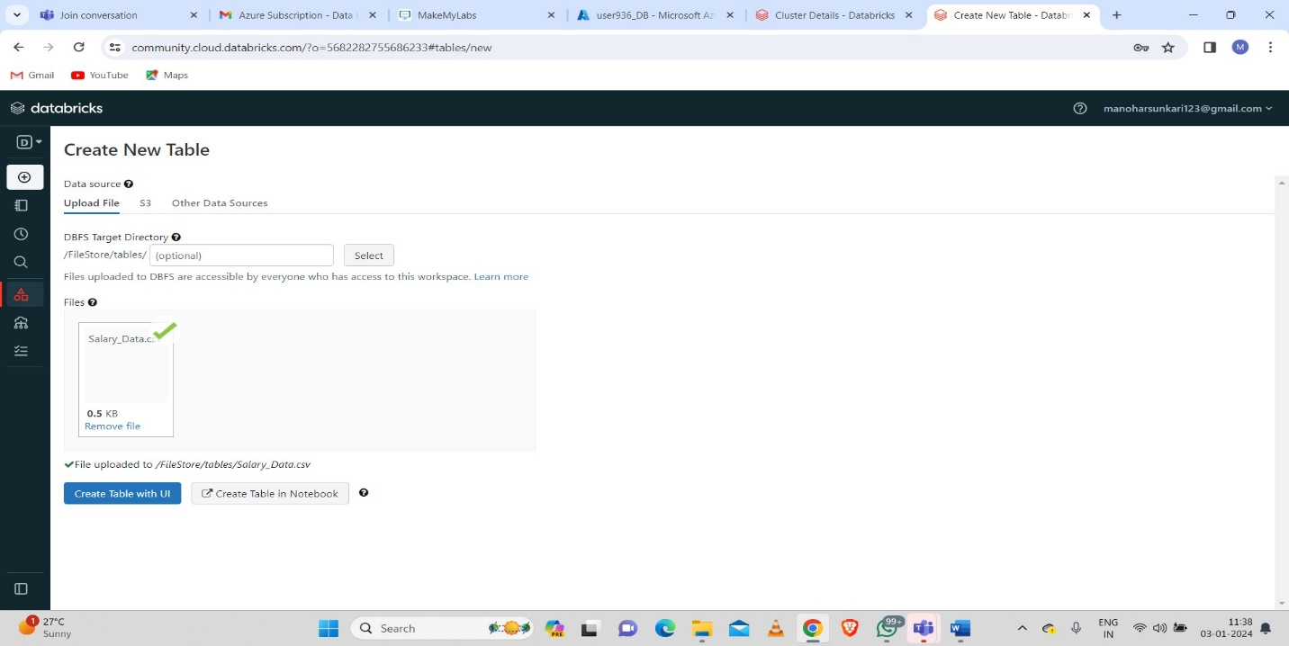

* Creating a cluster

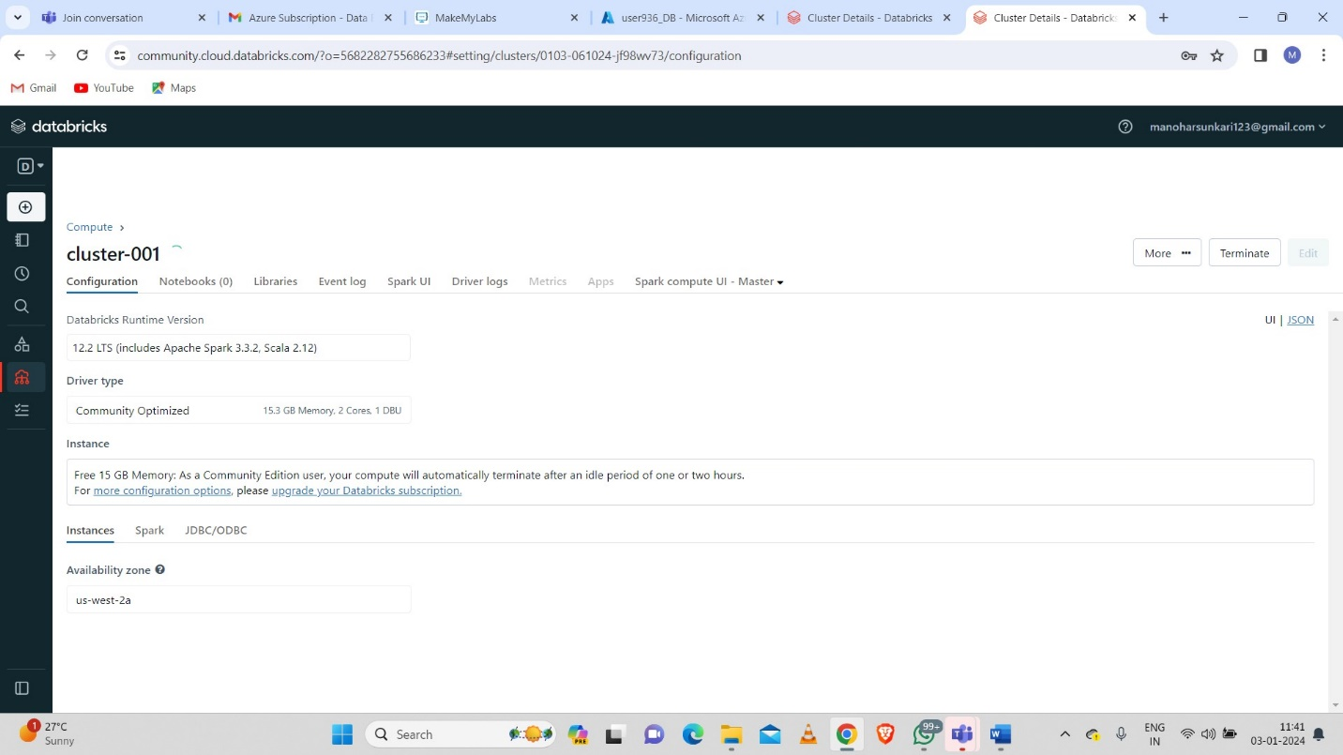

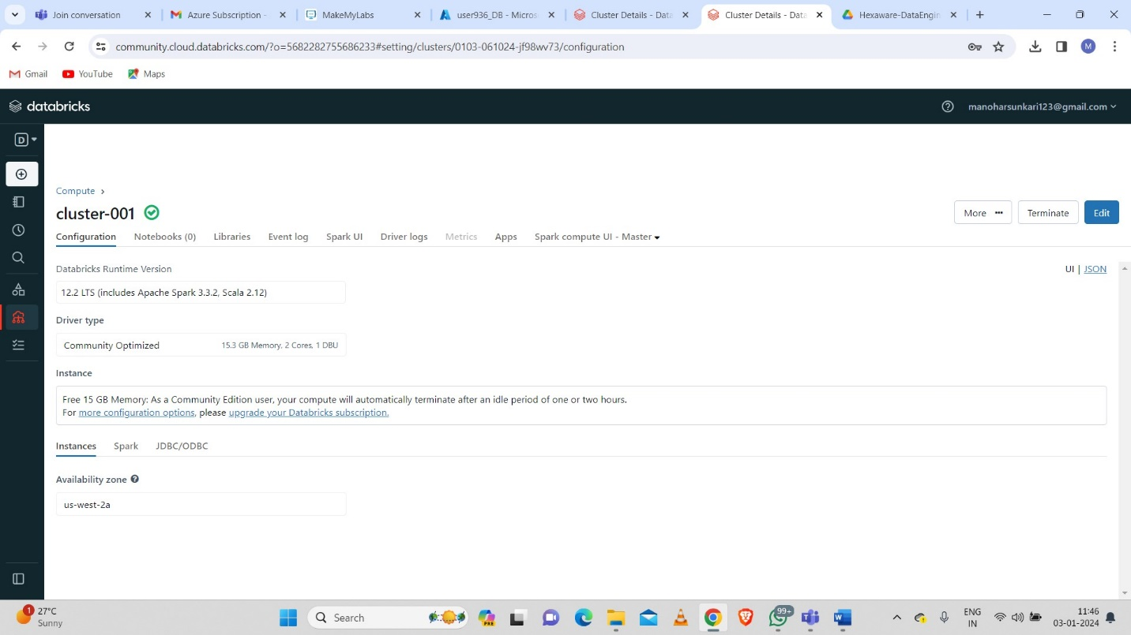

After the creation of table and cluster we need to select the cluster.

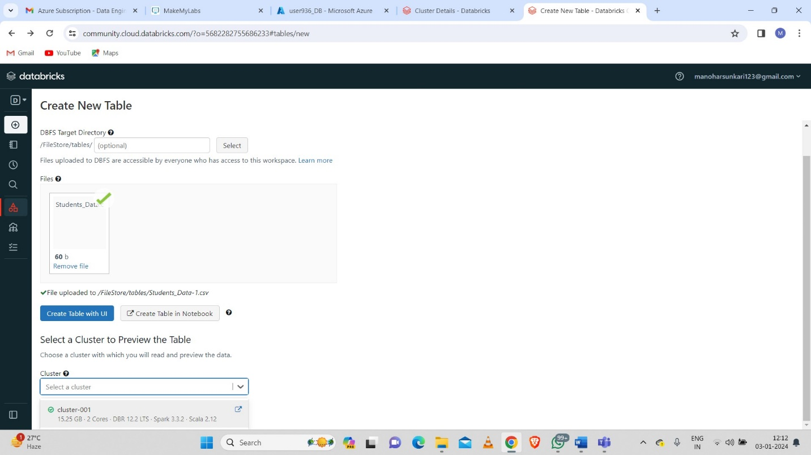

After selecting the cluster we need to open the tab “create table in notebook”

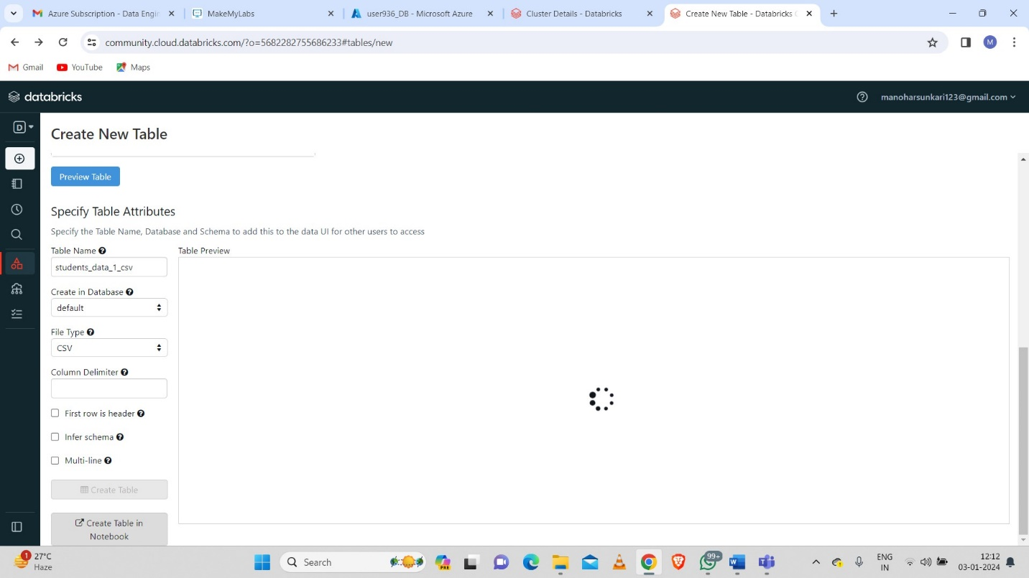

* Delta live tables:

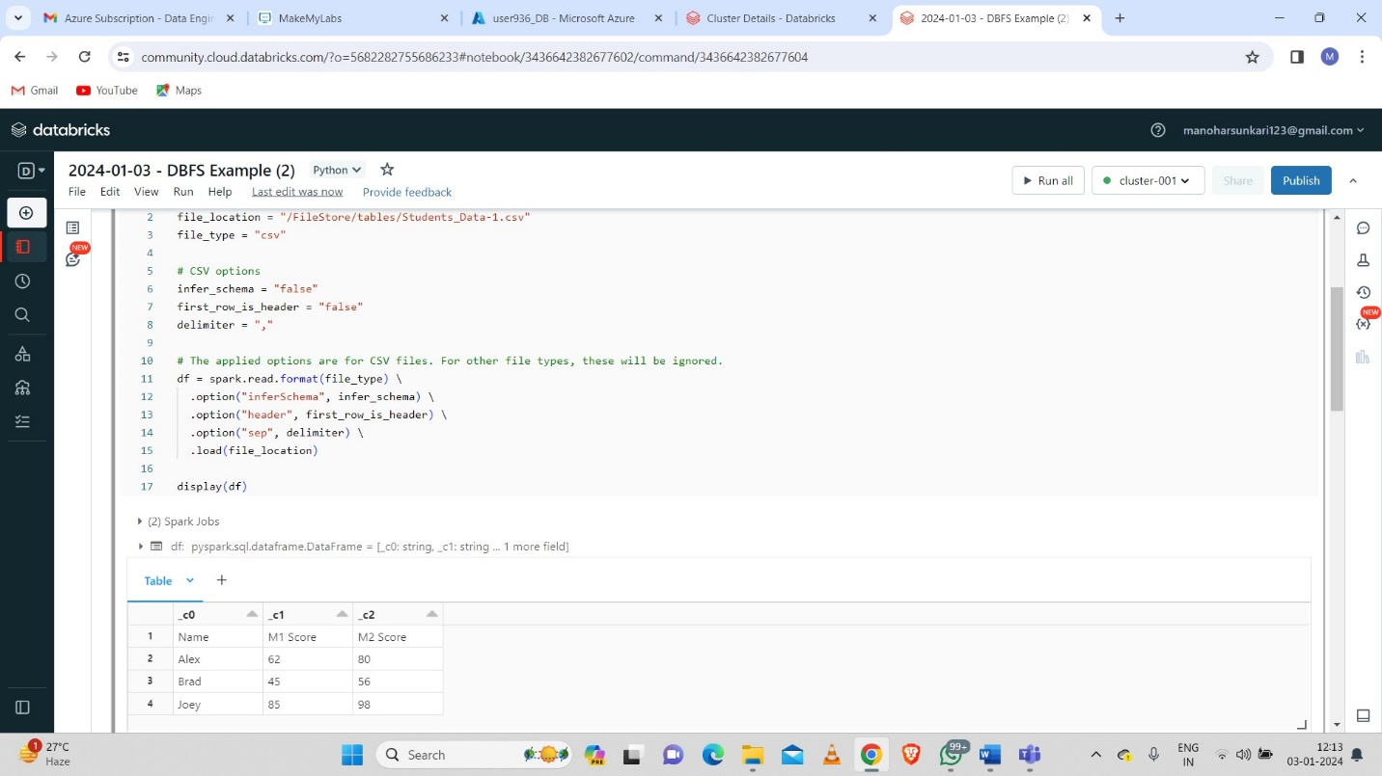

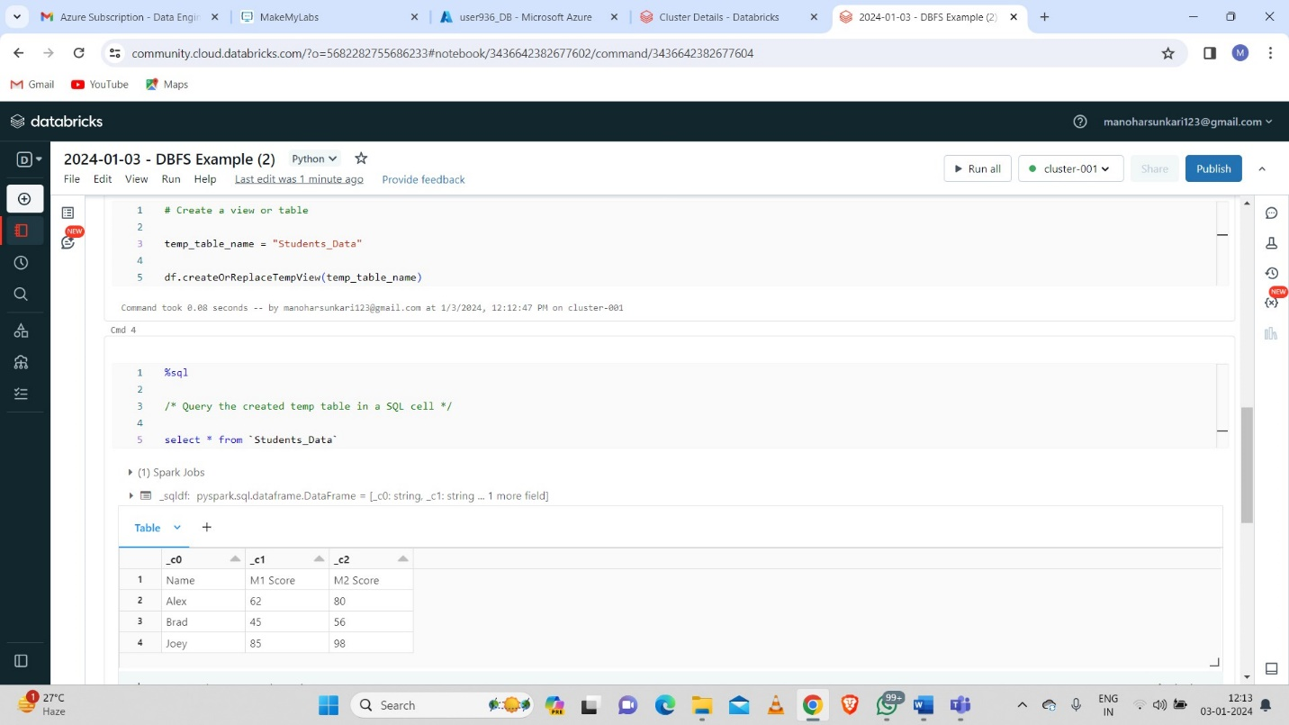

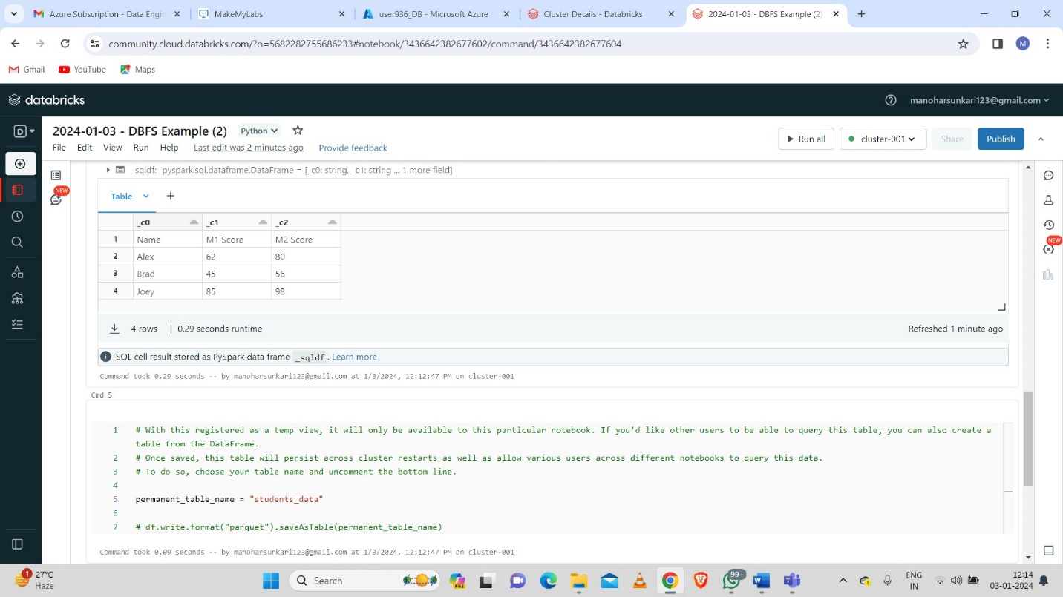

And discussed about project overview.

**Project Overview:**

We seen two projects how to build and how to make the project documentation.

**Documentation**:

**Introduction**:

**How it works:**

**Project Requirement:**

Data ingestion

Data Transformation

Data Reporting

Data Analysis